##$$Determination of the Principal Stress Axes
(Paleo Stress-Ellipsoid)

This program calculates the orientation of the three principal stresses σ1, σ2 und σ₃ from slickenside planes and striations on them. The polarity of the striation lineation (hanging block up or down) must be clearly defined in the field. The algorithsm was developed according to the dihedra method of ANGELIER & MECHLER (1976).
Data input is the same as in the other programs.
##$$KK>>Striation

A striation is a lineation on a fault plane, caused by movement of the hanging block. Such a plane is a slickenside plane. Striations mark the direction of the 'maximum resolved shear stress' (MRSS). They have a polarity.'
##$$KK>>Slickenside (Plane)

Slickensides are planes of movement between two blocks of rock. Often they are recognised by a polished surface. Lineations on such planes (striation) show the relative movement of the blocks.
##$$KK>>Dihedra Method

This method is used to determine the directions of the three principal stresses (σ₁, σ₂, σ₃) from slickenside planes and striations.

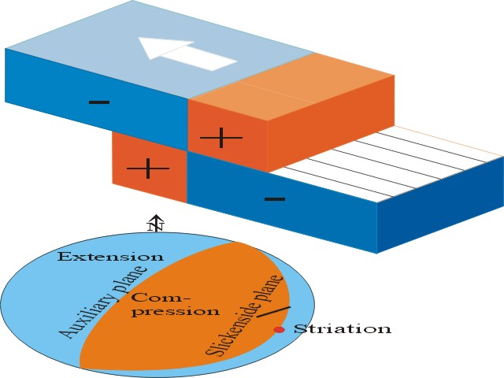

The slickenside plane is drawn as a great circle into a projection. Then a great circle is drawn normal to the striation (auxiliary plane). These two planes divide the globe into an extensional and a compressional dihedron.
If compressional and extensional dihedra of several displacement data are superposed, the intersection of compressional dihedra contains σ₁, and the intersection of the extensional dihedra contains σ₃
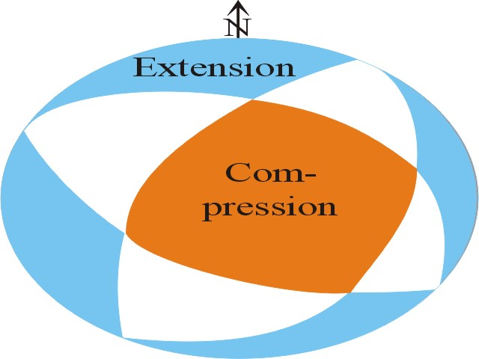
##$$Manual Input of Displacement Data

The form for manual input of slickenside planes and striations is similar to the previous programs. After clicking on the 'start' button, you put in the azimuth and dip of the slickenside plane, followed by azimuth and dip of the striation. The dip angle is positive if the plane is a reverse fault, and negative if the plane is a normal fault. For positive dip angles you may drop the '+' sign.
The input of a fabric element is terminated by 'OK' or 'Enter'. The input is shown in the list field. Measurement errors which produce an offset between the striation and the slickenside plane, are corrected automatically.
Input is terminated by 'terminate data input'. This activates the menus 'Save data', 'Printer', and the button 'plot'. The 'plot' button opens the plot form. Maximum number of data shows the value which is written in Fabric7.ini.
##$$KK>>Normal Fault

A fault plane with downward movement of the hanging block.
##$$KK>>Reverse Fault

A fault plane with upward movement of the hanging wall.
##$$ Input of Displacement Data from a File

After pressing the button 'Start' the list field on the right side ('select files') shows the content of the directory whose path is saved in Fabric7.ini. If this field is empty and the message 'no file found' appears, the data path can be changed after pressing the button 'find data path'.
Click on the files you want to use. These files appear in the middle field ('selected files'). Files can be removed from this list by clicking on them.
The button 'selection ok' terminates the choice of files.
The button 'plot' opens the plot form. The data of the files used appears in the left field.
The extension of the files and the path chosen appear under the left list.
##$$Plot of the Paleo Stresses

The compressional areas are drawn with contour lines in the Lambert projection. These lines separate areas with different amounts of compression (>20%, >40%, >60%, >80%, > 95%).
In the menu 'Colour\Contour lines' you can also choose different grades of gray for the plot of contour lines.
In the menu ‚Contouring methods’ further methods for the visualisation of counting densities are offered.
The menu ‚smoothing factor is used only for the Scalar product-method aktiv.
The Menu ‚Diagram’ ist the same as in the other programs.
The calculated values 'maximum' and 'minimum' allow an estimation of the consistency of the data set. In the ideal case the maximum equals the number of data, and the minimum is zero.

# Paläospannung
$ Paläospannung
# Striemung
$ Striemung
K striation
> Hilfe1
# Harnisch
$ Harnisch
K slickenside
> Hilfe1
# Dieder
$ Dieder
K dihedra method
> Hilfe4
# EingabeSpannung
$ EingabeSpannung
# Abschiebung
$ Abschiebung
K normal fault
> Hilfe1
# Aufschiebung
$ Aufschiebung
K reverse fault
> Hilfe1
# DisketteSpannung
$ DisketteSpannung
# PlotSpannung
$ PlotSpannung

